Extra Guide: Using the Flir ONE App

To access the below guides and more on the app, go to the menu (three lines in the top left corner), then Help, and then How to use, and select the camera you are using (it will have a green dot by it). You can also check the camera's remaining battery in the menu.

- Measurements: Use the below instructions to have several icons on your screen which show different temperatures in your thermal image. You can have one which always shows the coldest place, one showing the hottest, and 3 others which you can move around.
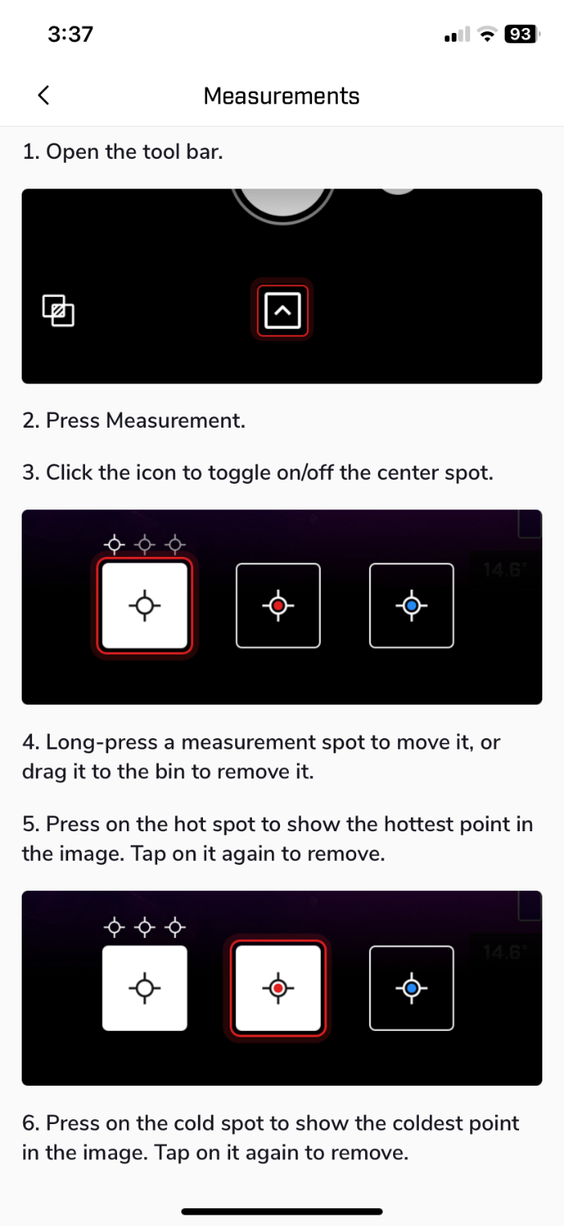

- Automatic/manual scale: The temperature scale is set to automatic by default, meaning cold elements like the sky can make everything else appear hotter in comparison, or vice versa with hot elements like people. To prevent skewed images, ensure only the house is in the frame (no sky) or switch to manual mode using the instructions below. For the manual setting, keep the temperature range between 10°C and 15°C. For example, if the outside temperature is 5°C, set the scale to 5°C–15°C.
