Receive a free thermal survey of your home
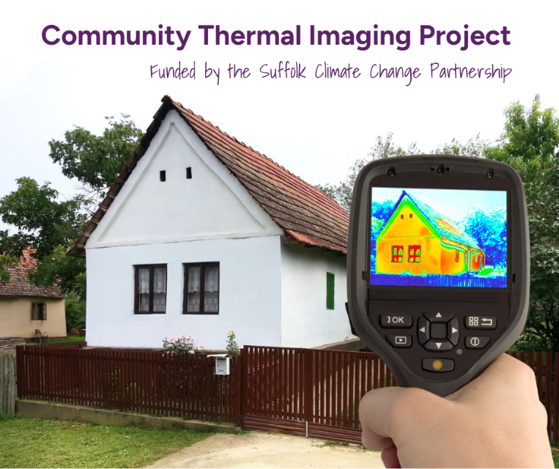
(INSERT GROUP NAME) is offering free thermal images of homes in the (LOCATION) area from (INSERT DATE) to (INSERT DATE).
Volunteers from your community will visit your property with a thermal imaging camera and plenty of helpful information and guidance to help you with next steps.
In just a 20-minute visit, you could learn where heat is escaping from your home and how to insulate it better. This could save you money on your energy bills, keep your home warm and lower your carbon footprint. The volunteers will not need to come inside your home and the thermal imaging camera will not be able to penetrate your windows.
To book your visit, contact us with your preferred dates on (EMAIL/PHONE NUMBER).
The Thermal Imaging Project is funded by the Suffolk Climate Change Partnership which brings all Suffolk councils together to better equip Suffolk for our changing climate. To find out more about their mission go to sustainablesuffolk.org.uk

