Sign up now to help keep your neighbourhood warm for winters to come
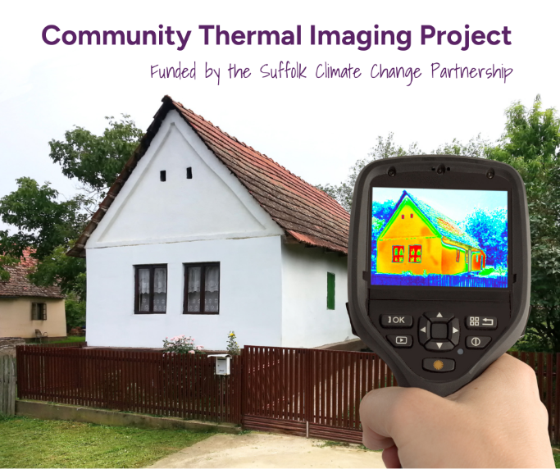
(INSERT NAME OF COMMUNITY GROUP) are looking for volunteers to help carry out thermal imaging surveys in your local area.
The Thermal Imaging Project is funded by the Suffolk Climate Change Partnership which brings all Suffolk councils together to better equip Suffolk for our changing climate. The Partnership is loaning out thermal imaging cameras for DELETE AS REQUIRED: community groups/Parish Councils/Town Councils like us to use. We need your help to attend homes in your area and take photos using a thermal imaging camera.
Residents will be able to see where their home is losing heat and we will be able to give them advice about how they can keep the heat in! This can save residents money on their energy bills, keep families warmer and make homes more carbon conscious.
The surveys in your area will take place from (INSERT DATE) to (INSERT DATE). You do not need to have any experience or prior knowledge to volunteer, all training and equipment will be provided. To get involved, contact us on (INSESRT EMAIL/PHONE NUMBER).

